The Czech Customs Directorate General
-
The International Road Transport Union (IRU)

The electronic communication between TIR-EPD application and NCTS – TIR application of the Czech Customs

Document

Ver.: 3.0
Date: 27.10.2022

- Purpose of the document
The objective of this document is to describe and define the way of communication between the TIR Electronic Pre-Declation system (TIR-EPD) and the Czech Transit system. The communication is a „two-way communication“ using the Virtual VAN Operator (VVAN) which is provided by the Czech Customs.
  - TIR-EPD is a web application provided by the IRU and enables its users to submit their transit (TIR) data to the Czech Customs Administration.
  - The Czech transit system is the National Transit Application (NTA) running on a HW placed in the Czech Customs Directorate premises. The NTA processes the TIR data which are exchanged in the form of structured electronic messages between the TIR-EPD and the NTA and further sends them to countries of destination involved in the NCTS project (EU countries).
- Data exchange
  - As the common communication channel the Internet network connecting the Czech Customs site through the Virtual VAN Operator is used.
  - The electronic messages are in XML format, electronically signed by a qualified electronic signature (certificate).
  - In the direction from TIR-EPD to NTA the IRU certificate is used.
  - In the direction from NTA to TIR-EPD the Czech Customs Directorate certificate is used.
  - The validity of the certificate is one year. An automatic email notification of the certificate expiration is automatically sent by the Certification Authority to the certificate owner before the certificate expires.
  - The public part of the new certificate is sent to the other party at least two working days before the certificate expiration to provide for its implementation in the system.
  - The electronic messages are listed in Annex 1. The format of the messages has to follow the documentation for SW developers available at https://www.celnisprava.cz/cz/clo/e-customs/ncts/Stranky/dokumentace-pro-vyrobce-SW-UCC-NCTS.aspx including the list of amendments (NCTS ECR KEL).
  - Possible scenarios of message exchange are listed in Annex 1.
  - In case the message sent to the NTA is functionally erroneous the NTA system replies sending an error message CZ056C –in this case the declaration is not submitted and the TIR-EPD user is informed about the error of the message he/she sent.
  - The error must be visible in TIR-EPD for the user to be informed that the submission was not successful.
  - Error codes are listed in Annex 2.
- Customs clearance
  - TIR-EPD user submits a transit declaration – message CZ015C.
  - In case of an erroneous message the NTA rejects it sending the functional error message CZ056C or CZ917C in case XML error.
  - In case of a correct message the NTA sends the registration message CZ0928C.
  - The trader asks for his data acceptance at a customs office referring to Carnet TIR Number.
  - The customs officer identifies the declaration data in the system, compares the data with Carnet TIR document and accepts the declaration – message CZ028C.
  - In case the data do not comply with the Carnet TIR document the customs officer does not release the declaration – message CZ009C.
  - In case of compliance the customs officer releases the declaration – message CZ029C.
  - On TIR carnet Holder’s request or if no usage of the data has been made within 30 days the declaration is automatically deleted – message CZ051C.

- SW Documentation
  - The actual documentation (cs) is located at https://www.celnisprava.cz/cz/clo/e-customs/ncts/Stranky/dokumentace-pro-vyrobce-SW-UCC-NCTS.aspx.
  - The new version changes are published in KELs (Known Error List) (cs).

Annex 1 –Scenarios

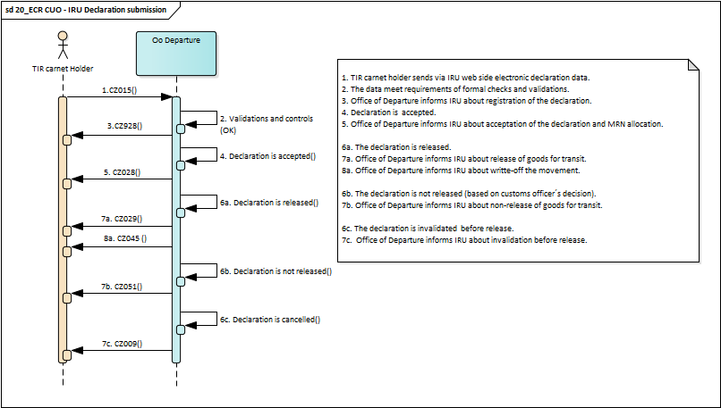

Annex 2 – Error code list

0 |  | Generic error
1 |  | Invalid group repetition
2 |  | Missing required element
3 |  | Redundant element, cannot be used
4 |  | Element value too short
5 |  | Element value too long
6 |  | Invalid type characters
7 |  | Value not a part of the applicable code list
8 |  | Group/element not conform with rules
9 |  | Error in guarantee
10 |  | TARIC check failed
90 |  | Unknown LRN or MRN
91 |  | Duplicate LRN
92 |  | Message out of sequence
93 |  | Invalid MRN

